

**Business Analysts Guide**

**PowerEditor Version 5.10**

Last Update: September 7, 2018 Version 5.10.0

Notice: This document includes confidential and proprietary data that is within the scope of non-disclosure agreements between MindBox and its alliances. The document shall not be duplicated, used or disclosed -  
in whole or in part - for any purpose other than that specified within the scope of such an agreement. Acceptance of this document presumes adherence to the above conditions.

The PowerEditor documentation suite includes the following materials:

PowerEditor Business Analysts Guide

PowerEditor Custom Reports Guide

PowerEditor Installation and Customization Guide

PowerEditor Reference Manual

PowerEditor Release Notes

PowerEditor Rule Writers Toolkit

PowerEditor Web Service API Guide

*Release Notes* for earlier versions back to and including 4.0 are also provided in the release package. For technical assistance with upgrading or any other PowerEditor-related issue please contact CoreLogic Technical Support at 1-855.369.2410, or [ADESupport@corelogic.com](mailto:ADESupport@corelogic.com)

**Table of Contents**

1. Getting Started in PowerEditor 4

1.1 Guidelines 5

1.2 Templates & Rules 6

1.3 Dates & Activations 9

1.4 Context: Entities, Products, and Categories 11

1.5 The Top Four Business Analysts Screens 13

2. More About PowerEditor: Beyond Guidelines 18

2.1 Deployment & Status 19

2.2 The MindBox Decision Engines & Their Phases 19

2.3 The Object Model: Data Classes & Attributes 22

2.4 Parameters 25

3. Finding & Retrieving Guidelines 25

4. Working With Guidelines 27

4.1 Creating a New Guideline Activation 27

4.2 Creating a New Guideline 29

4.3 Using One Guideline to Make Another One 30

4.4 Taking Status Into Account 30

4.5 Validation: Running A Data Entry Check 31

4.6 Making Group Changes to Multiple Guidelines 31

4.7 Deleting Guidelines & Activations 32

4.8 A Quick Tour of PE’s Data Entry Fields 32

4.8.1 Check Boxes and Drop Down Lists 32

4.8.2 Entering Numeric Ranges 33

5. Editing Messages 34

5.1 Using Message Arguments 35

5.1.1 Attribute Arguments 35

5.1.2 Column Arguments 36

5.2 Message Syntax 37

5.3 Anomalies In An Attribute Name 37

6. Working With Products And Other Entities 38

6.1 Retrieving Product Information 39

6.2 Editing Product Information 39

6.3 Adding a Product to an Existing Category 39

7. Reports 39

Appendix: Glossary 41

INTRODUCTION

PowerEditor (PE) is the application used to develop and maintain automated business policies in a MindBox decisioning system. This guide was written for people who will be using PowerEditor to maintain the information stored in their PowerEditor knowledge base, a group collectively known as Business Analysts, or BA’s, in this document.

Business Analysts, after reading this guide you will understand how to:

* find and display guidelines using a wide variety of search criteria
* update existing guidelines and create new ones
* manage guidelines effectively using dates, date synonyms, and group editing functions
* create new versions, called activations, of guidelines
* retire/archive guidelines
* add a product to a product category
* update definitions of products and other entities in PE, e.g., programs, distribution channels, and investors
* manage associations between products and guidelines
* edit and create messages delivered to users when a business rule fires (executes)
* create PE reports

You will also learn about:

* the six components of a guideline
* PowerEditor templates and template rule logic
* product hierarchies and the relationship between guidelines and products
* data classes and attributes and the MindBox object model
* deployment status and the guideline development cycle
* decision engine phases and their relationship to templates and guidelines

This guide provides an introduction to these and other PowerEditor concepts. For additional information, including detailed procedures for completing all PE-related tasks, please consult the *PowerEditor Reference Manual.*

# Getting Started in PowerEditor

PowerEditor has many screens, depending on how your system’s configured you may have fifteen or twenty, or more. Don’t worry, a Business Analysts’ tasks are completed on just four of them: the Search Policies screen, the Edit Guideline screen, the Manage Guidelines screen, and the Manage Templates screen. These screens and their controls are covered in detail below. Should the desire to explore other PowerEditor screens arise, this Guide will provide you with the conceptual background you’ll need to understand what they’re used for.

This section, Section 1, introduces PowerEditor guidelines, templates, context, and activations. In Section 2 you’ll learn about more PowerEditor elements and some of the logic and intelligence in PE beyond the guideline level. Sections 3 and 4 provide basic instructions for retrieving and editing PowerEditor guidelines. Section 5 discusses the tools used to maintain and create customized messages; Section 6 introduces products and product maintenance tasks, including working with categories. Section 7 provides instructions for creating basic PowerEditor reports. A PowerEditor glossary appears in the appendix.

## Guidelines

Guidelines may be the most fundamental PowerEditor element: guidelines express your company’s business policies and product information in PE-readable form. With their rows and columns they resemble a spreadsheet and so are sometimes called guideline “grids.” Figure 1 gives an overview of the Edit Guideline screen.

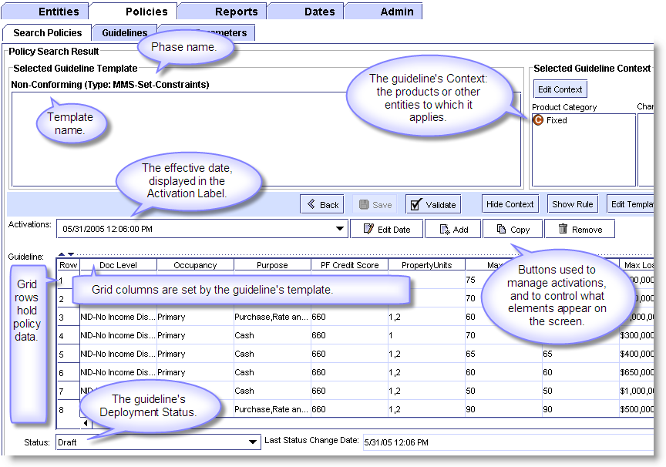

Figure 1: Components of a guideline.

Among the blue tabs across the top of Figure 1 are two white tabs: Policies and the sub-tab Search Policies. In this and other full screenshots below, find the white tabs to see which PE screen is being shown.

A PowerEditor guideline has six main components:

* a grid
* a context
* an effective date
* a deployment status
* a template, and
* an associated decision engine phase.

A guideline's columns and phase are determined by its template.

The information in a guideline grid might come from an underwriting manual, a loan program matrix, or a rate sheet. A guideline might pertain to a particular product, to a group of related products, or to property in a particular state. Its information might apply to stipulations, to pricing adjustments, or it might express qualification requirements.

## Templates & Rules

A PowerEditor template is a reusable blueprint, or structure, that determines which data elements will be used in a guideline and the logical relationships between those elements. Templates speed up the process of implementing new business policies in PE. A template can be used by one or more guidelines. Figure 2 shows the Manage Templates screen.

Every template has a description, one or more columns, and a rule. Template are associated with a specific engine phase that specifies when guidelines associated with this template will be utilized by the MindBox engines during processing. Templates can also be used to deliver customized text messages to users. A Business Analyst’s template-related tasks are usually confined to editing and creating messages.

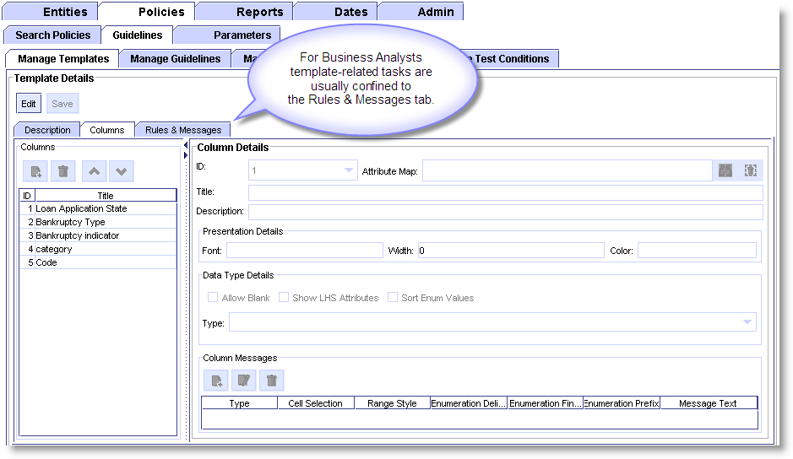

Figure 2: The Manage Templates screen.

A template’s rule describes the conditions under which the rows in a guideline will execute, or “fire,” and the action that should subsequently take place. A template’s rule is also called its rule logic. The phrases of code that make up a rule’s logic are called rule clauses; we’ll be looking at how clauses are constructed later on. Figure 3 shows the basic construction of a template rule.

A template rule states, “If *a* is true, and *b* is true, then do *c.*” For example,

**IF: Equals:**

Doc Level = No Income Disclosure

(and) Occupancy = Primary Residence

(and) Loan Purpose = Purchase, Refi and Term Refi

**THEN Set: Equal To:**

Max LTV = 85%

(and) Max Loan Amount = $700,000

In geek-speak, this translates to: “IF the value of data object *a* matches the value stored in guideline column *b,* THEN set the value of data object *c* to the value in column *d.*”

Data on the IF side of a rule typically comes from “incoming” sources such as a 1003 form or a credit report. Data on the THEN side of a rule tends to be computed, or entered by a Business Analyst.

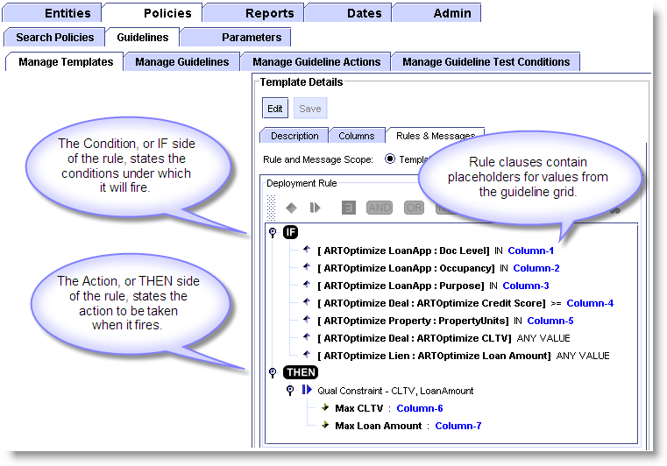

Figure 3: The If/Then logic in a template rule.

On the Edit Guideline screen the Show Rule button displays the rule logic associated with a given guideline. Conversely, if the rule is already being displayed toggling the Show Rule button will turn it off. Figure 4 illustrates the relationship between a guideline’s columns and its rule.

A template’s message is provided to customers (or other users of the decisioning system) when a rule executes, so you won’t see the final output of a message until it’s guideline has been deployed and executed by the rule engines. Messages can be customized by inserting values from a guideline grid, or from anywhere else in PowerEditor. More on working with messages in Section 5.

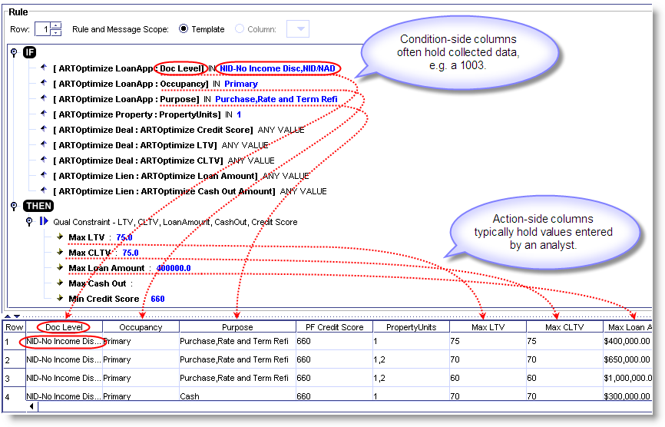

Figure 4: Rule clauses and guideline columns.

## Dates & Activations

A guideline’s activation date is its effective date, and an activation is a version of a guideline that is effective for a specific period of time. A guideline’s activation period, as determined by its start and end dates, is called its effective date range. PowerEditor dates appear in month/day/year format (mm/dd/yyyy), e.g. “01/12/2006,” and some include hour and minute information as well (hh:mm).

On the Edit Guideline screen the Activations field is known as a guideline’s activation label. Use this field to activate and retire guidelines and to create new versions as needed. Though different activations of a guideline have different effective dates and grid values they will all share same template and context. Other objects in PowerEditor also have activation and expiration dates.

**Date Synonyms**

A date synonym is a “date stand-in” that allows you to associate a descriptive text string with a particular date, e.g. New Years Day, or “June 15 Rollout.” Figure 5 gives some examples.

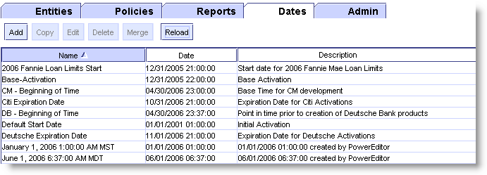

Figure 5: Examples of date synonyms.

A synonym can be used in most places a date is used in PE. Changing a synonym’s date changes the date everywhere the synonym is used. For example, if the June 15th Rollout slips, change it’s synonym’s date and PE will makes the change for you wherever the synonym was used.

Use the Dates tab to create, modify, and delete date synonyms in PE, or use the synonym icons that appear next to most date fields. Clicking the Add icon brings up the New Synonym dialog box (Figure 6).

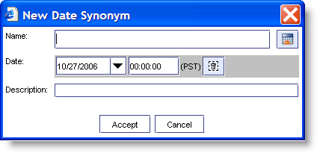

Figure 6: Creating a new date in PE.

Use the Show Date Names checkbox on the Edit Guideline screen to change the way dates are displayed, toggling it to display synonym names and actual dates (Figure 7).

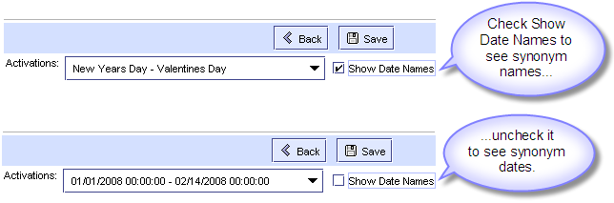

Figure 7: Date synonyms and the Show Date Names box.

## Context: Entities, Products, and Categories

PowerEditor comes with a set of objects called entities. Entities are used to hold information about things you want to associate with guidelines. Mortgage examples could include products, programs, distribution channels, or investors. Product entities—being the most common—are used in the examples that follow, but you can substitute any type of entity and it will work the same way. PowerEditor supports an unlimited number of entities and entity types.

Entities tie specific guidelines to specific products (or programs, channels, etc.). This association provides each guideline with its context. In other words, context is the set of entities, e.g. a particular group of products or programs, to which a guideline applies.

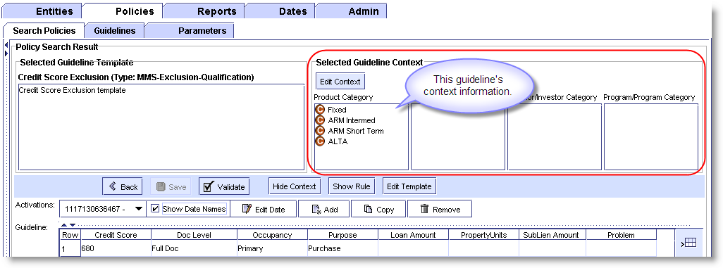

Figure 8: Context information on the Edit Guideline screen.

Entity information is typically grouped into categories*.* For example, by using categories you can create guidelines for all conforming fixed rate products, or for all ARMS, or for specific Jumbo Fixed 30 products. Products can be linked to multiple categories, to a single category, or to none at all. Here are some sample product categories:

Type Category Amortization Category Term Category

Jumbo Fixed 3 year

ALT-A ARM 15 yr

Super Jumbo Balloon 30 yr

Products typically belong to several categories. Categories for the product "Jumbo Fixed 30" might include:

Type Category Amortization Category Term Category

**Jumbo** **Fixed** 3 year

ALT-A ARM 15 yr

Super Jumbo Balloon **30 yr**

Category information is organized hierarchically in PE. Figure 9 shows a sample product hierarchy for a mortgage application. Expanding the branches will display the contents of each category and sub-category.

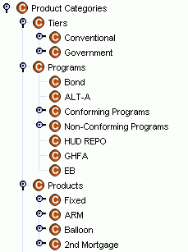

Figure 9: Sample Product Hierarchy

PowerEditor provides tools for retrieving and processing guidelines based on their product type, category, or combination of categories. Figure 10 shows the result of a category-based search for Non-Prime products.

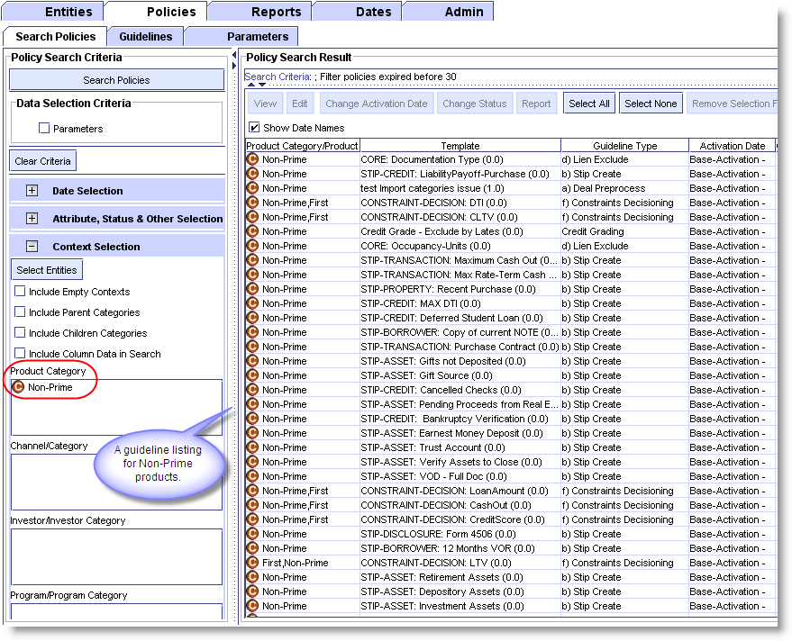

Figure 10: Result of a guideline search for Non-Prime products.

Entities also provide valuable editing shortcuts:

* link a guideline to a category and it’s automatically associated with every product in that category.
* add a product to a category and it’s automatically associated with every guideline in that category.

To summarize this section: PowerEditor guidelines hold your business policy information in PE-readable form. Each guideline row:

* has the same logical structure, i.e. has the same columns and rule logic, provided by the guideline’s template;
* applies to the same products (programs, channels, investors), provided by the guideline’s context;
* is active for the same period, specified by the activation date.

## The Top Four Business Analysts Screens

The PowerEditor screens used most frequently by Business Analysts are the Search Policies screen, the Edit Guidelines screen, the Manage Guidelines screen, and the Rules and Messages screen (under the Manage Templates tab). A discussion of each of them appears following this overview.

**BA Screen #1:** Search Policies.

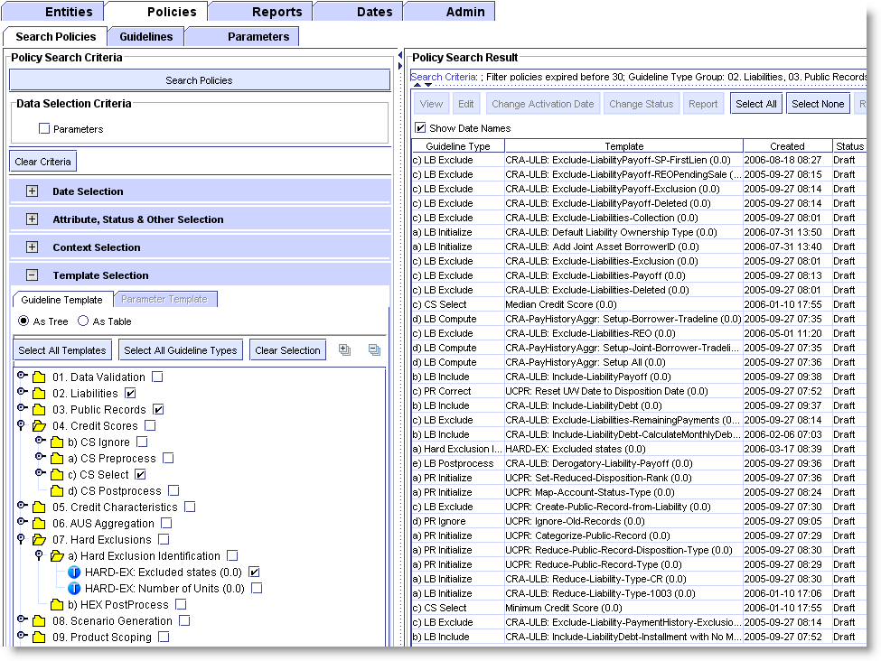

Figure 11: The Search Policies screen.

* The Search Policies screen is used to retrieve guidelines using a wide variety of search criteria, and to view guidelines and their activations in list form. This screen is used to perform group date and status changes, and to generate reports.

**BA Screen #2:** The Edit Guideline screen.

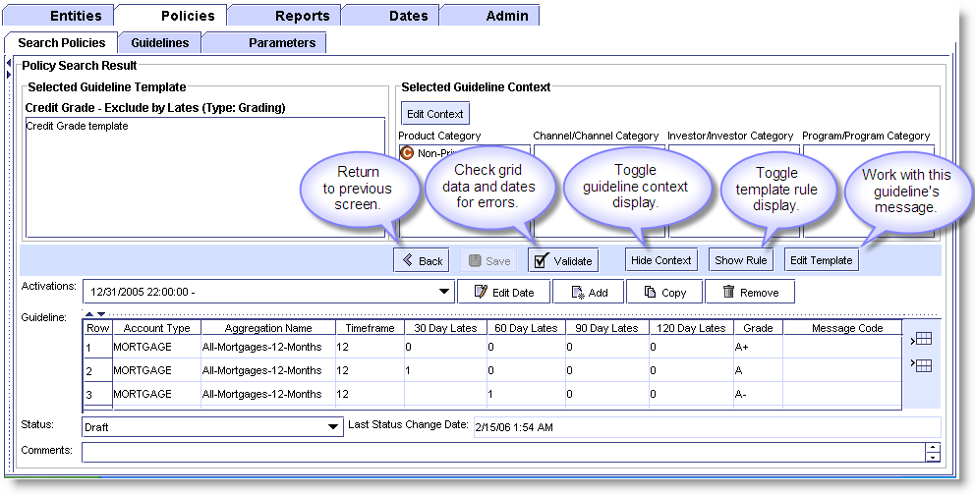

Figure 12: The Edit Guideline screen.

* The Edit Guideline screen appears when you double-click a guideline in the Policy Search Result window or create a new guideline. Use it to enter, modify, and delete guideline data and to add or remove activations.

**BA Screen #3:** The Manage Guidelines screen.

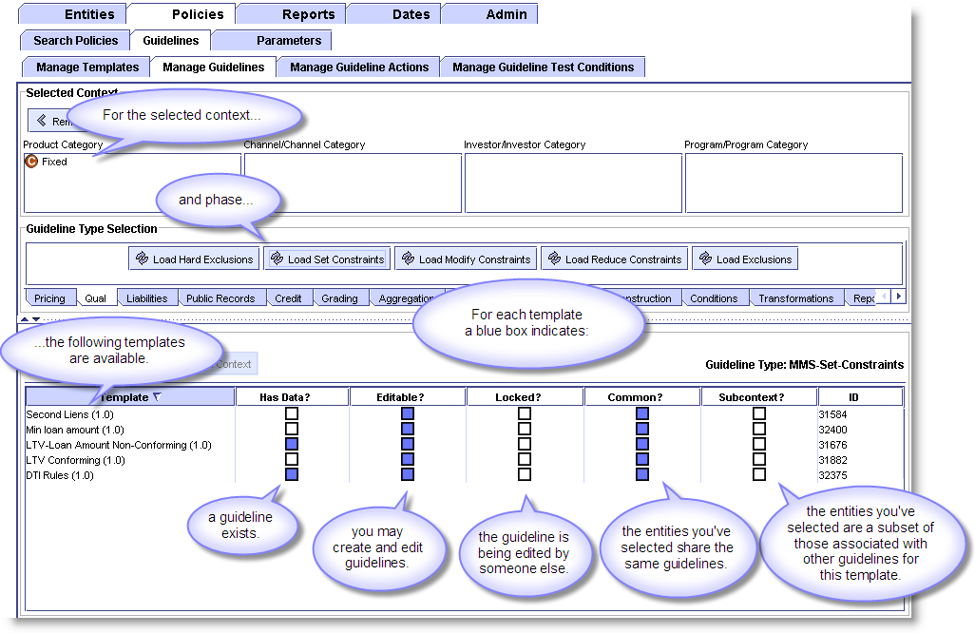

Figure 13: The Manage Guidelines screen.

The Manage Guidelines screen is used to create new guidelines.

PowerEditor won’t let you accidentally create guidelines with different contexts for a single template. The lower section of this screen provides information about what guidelines exist for a template, their context, and whether the context you’ve selected creates a conflict. Below you’ll find instructions for interpreting the boxes and correcting a problem if one arises. Read it if you’d like, or just rest assured that PE won’t let you create guidelines with conflicting contexts.

For each template, and the context you selected, a blue box in the column:

Has Data? – indicates a guideline already exists.

Locked? – indicates the guideline is being edited by someone else.

Common? – indicates the template has other guidelines that use the same combination of entities you have chosen, i.e., the entities you choose share the same guidelines.

Subcontext? – indicates the entities you’ve selected are a subset of those associated with other guidelines for this template.

Editable? – indicates there’s no conflict and you may create the new guideline.

The Editable box will be checked when:

Locked is not checked

and: Common is checked

and: Subcontext is not checked

Note that Common and Subcontext are only taken into account when entities are used in the context (e.g., Product1 and Product2), not categories (e.g., Fifteen Year Products and Jumbo Products).

Let’s run through an example. Say you want to create a new guideline that and you currently have in your system:

two guidelines: Guideline A and Guideline B

one template: Template C

and three products: Product 1 (P1)

Product 2 (P2)

Product 3 (P3)

P1 and P2 are associated with Guideline A (i.e., they apply to the same guideline).

P3 is associated with Guideline B (i.e., P3 applies to a different guideline).

If you select P1 and P2 for your context:

* Common will be checked because the entities you’ve selected share the  
  same guidelines.
* Editable will be checked, and you can create the guideline.

If you select P2 and P3 for your context:

* Common will not be checked because P2 and P3 are associated with different guidelines.
* Editable will be not be checked, and PE won’t allow you to create the guideline.

If you select only P1 for your context:

* Common will be checked because one of the entities you selected is used by an existing guideline.
* Subcontext will be checked because you have not selected *all* the products associated with an existing guideline (in this case, P2). In other words, only a subset of the products associated with Guideline A have been selected.
* Editable will not be checked and you won’t be allowed to create a guideline.

In this case you have the option of using the View Selected Context button, which tells PowerEditor to add the missing entity to the context for you. Once it has, Common and Editable will be checked and you’ll be able to create the guideline.

**BA Screen #4:** The Rules & Messages tab of the Template Details screen.

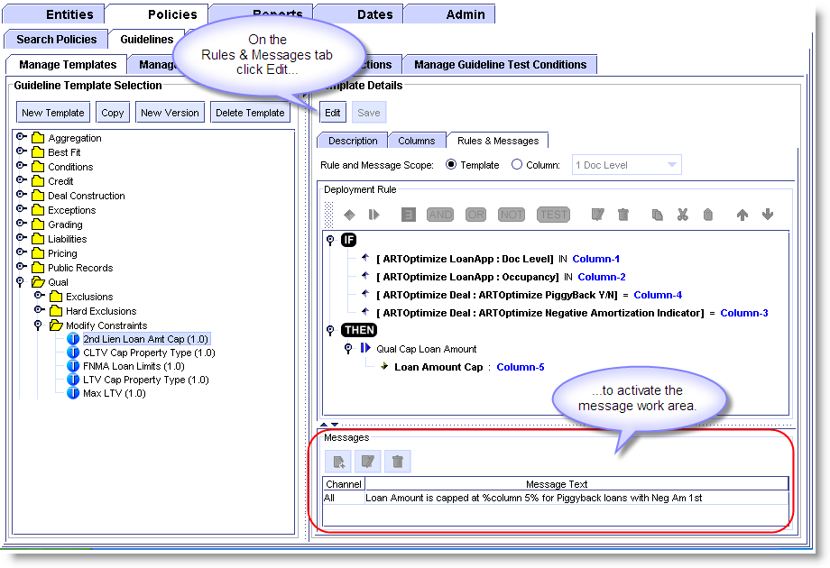

Figure 14: The Rules & Messages tab.

Use the Rules & Messages tab on the Manage Template screen to edit, customize, and create messages. Template builders and rule writers also use this screen to construct and refine template definitions, logic, and rules.

# More About PowerEditor: Beyond Guidelines

This section introduces a number of other PowerEditor elements that extend beyond (or behind) the guideline level, and some of the PE logic and intelligence they provide. It’s not material you’ll be working directly with every day, but it will help you understand some of the other things going on in the screens you use regularly, and others you may encounter in your work.

It includes a basic discussion of:

* Deployment & Status – more about the Status field and the guideline development cycle.
* Parameters – a bit about these static elements.
* the MindBox object model – which defines how PE stores information about all the “things,” or data objects, in your business.

## Deployment & Status

A guideline’s deployment status indicates where it is in the system development cycle. Common status values include: Draft, Test, QA, and Production. Guidelines in Draft status are typically in a working state. Guidelines in QA status are ready to be tested; if problems are found they’re reset to Draft status until any bugs are fixed. Production guidelines have been tested and are ready for general use.

Deployment is the process of extracting all the information in PowerEditor, e.g., guidelines, rules and other PE data and converting it to ART*Enterprise code so it can be read and executed by the decision engine. The Deploy To Rule Engine screen allows Rule Writers and other administrators to deploy selectively, e.g. to deploy only guidelines with a status of Draft, those associated with a particular template, etc.

### Status-based Deployment Authorization

Prior to version 5.8.0, PowerEditor provided a single privilege for deployment. In version 5.8.0, PE supplies a deployment privilege for each deployment status. This allows setting up a user’s authorization in such as a way that he/she can deploy policies in Draft status but not in Production.

## The MindBox Decision Engines & Their Phases

A template’s phase (short for “engine phase”) indicates when it will be employed and processed by the decision engines. Different PE templates are processed at different phases. For easy retrieval, phases are bundled together into groups in PowerEditor. For example, phases in the Credit Scoring (CS) group include “CS Ignore,” “CS Preprocess,” “CS Select,” and “CS Postprocess.” A guideline’s phase is set by it’s template.

Actually, to say that templates and guidelines “have” phases is not entirely accurate—that’s a very guideline-centric view of things. In fact the opposite is true: phases “have” templates and guidelines. That is, in a given phase the engines use the information held in guidelines and templates to perform specific processing tasks.

Phases are depicted two different ways in PowerEditor. On the Search Policies screen they appear as yellow folders, with group folders at the top levels. Beneath them, the phase folders contain the templates for each phase. The folders and templates are listed in alphabetical order.

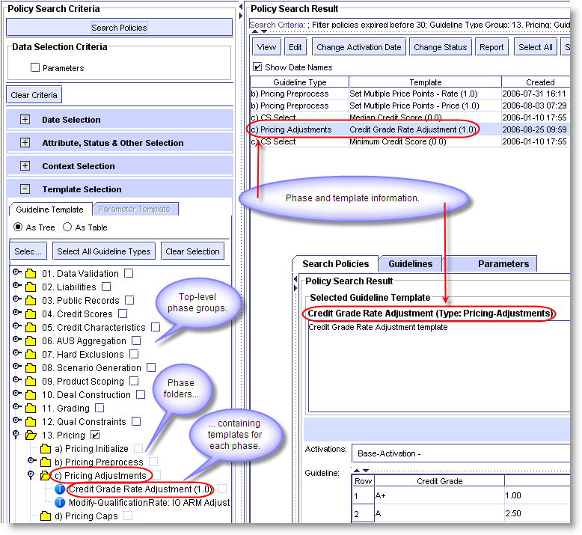

Figure 15: Phase information on the Search Policies screen.

On the Manage Guidelines screen phases and phase groups are depicted as tabs and buttons in order of engine processing, left to right across the screen.

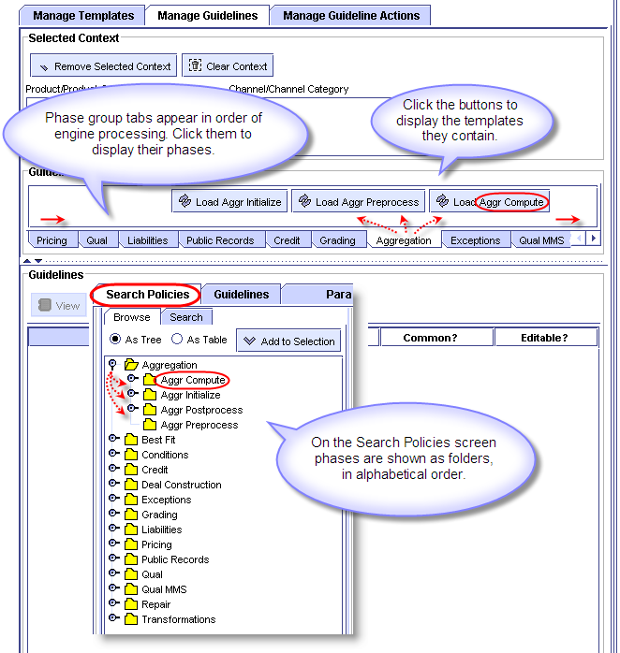

Figure 16: Phases two ways.

Information labeled variously, “Guideline Type” on the Search Policies screen, “Usage Type” on the Manage Templates screen, and just “Type” on the Edit Guidelines screen, is all phase-related. Just think “Phase” and you won’t get confused.

## The Object Model: Data Classes & Attributes

The MindBox object model is a fully-functional representation of the business data your company uses each day; i.e., it is a model of data “objects.” Because evidence of it is everywhere in PE, a basic understanding of your MindBox system’s object model will serve you well wherever you are working in PowerEditor.

In object-based computer systems, objects form the basic unit around which information about the world and the things in it are organized. Business objects are things a business keeps track of or utilizes in a business process. A business object could be a phone call, an invoice, a loan application, or a Customer Service Representative (depending on the business we’re talking about).

In an object model all the data objects in a system are identified, defined, and organized into categories called classes. A typical object model for a mortgage application includes classes like “Borrower,” “Property,” “Loan,” “Income,” and “Refinance.” Figure 17 shows some classes and attributes related to loans.

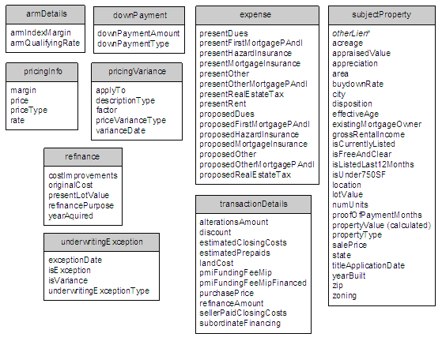

Figure 17: Classes related to the Loan object.

The model includes a description of each object’s properties. For example, we might note that a shirt's color is blue and its size is large. “Color” and "size" are attributes*,* and "blue" and "large" are attribute values. The class Borrower might include the attributes “Name,” “Address,” and “CreditScore.” Values of those attributes might be “Robert Smith,” “436 Main Street,” and “660.” The object model doesn’t contain any attribute values, but forms the structure in which the data will be held.

Template rule clauses are constructed of class and attribute names. Taken together, class and attribute name form a unique identifier for every piece of data in the MindBox system.

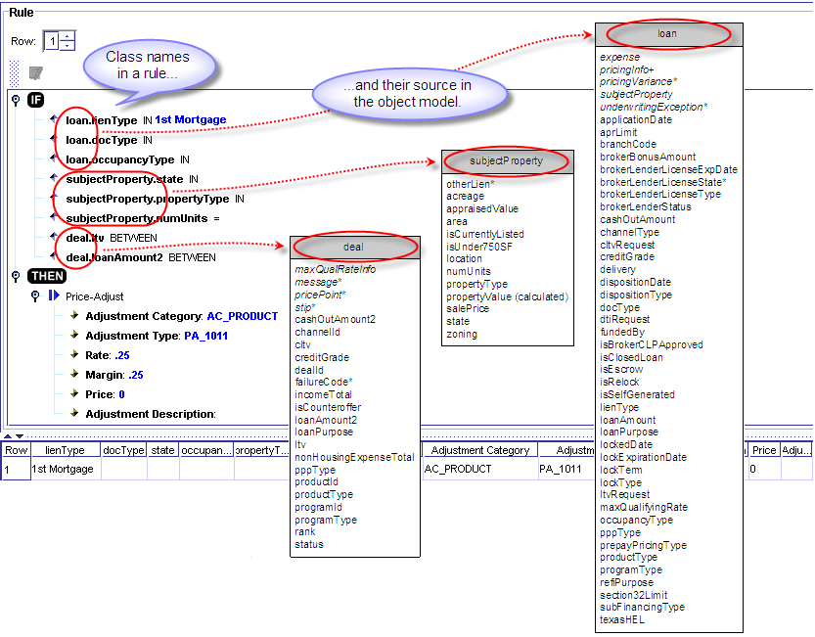

Figure 18: Rule clauses and their source in the object model.

The syntax of object names varies; both periods and colons are used to separate the attribute from the class name. Examples of data object names include:

* “Borrower.Credit-Score”
* “LoanApp.Purpose”
* “ARTOptimize FNMA Loan Limits: NumberOfUnits”
* “Deal_calc_a.dti”

Many mortgage object names are set by MISMO.

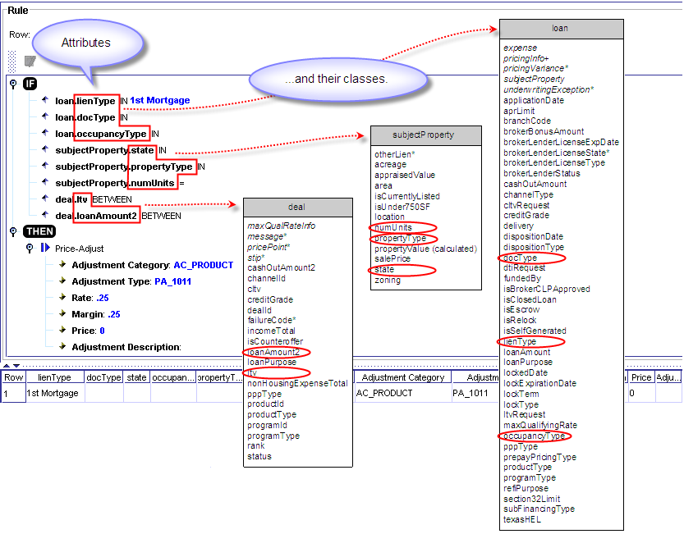

Figure 19: Attributes and their classes.

Figure 20 shows another view of class and attribute information in PE in the attribute lookup dialogue.

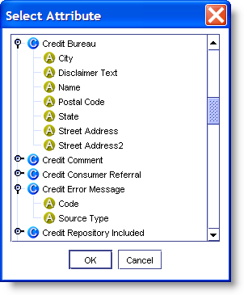

Figure 20: Another view of PE classes and attributes.

To summarize, all the things in your business system are represented in your object model. The object model determines the way this data is named, stored, and used throughout PowerEditor.

## Parameters

Parameter templates are a special type of template that contain relatively static (unchanging) information. Business Analysts work with parameters infrequently, for example, you might need to update a parameter when the FNMA loan limits change.

The “Add Parameter Criteria” checkbox at the top of the Search Policies screen allows you to include parameters in your search criteria, but you will rarely need to use it. The Policies tab is so named because in PE the term “policy” means both guidelines and parameters.

# Finding & Retrieving Guidelines

The Search Polices screen gives you access to every guideline and activation in the system, past and present. When working with existing guidelines this is the place to start. You can retrieve guidelines based on template, context, date, attribute, or status, and combinations thereof. Searching by template is probably the most frequently used option.

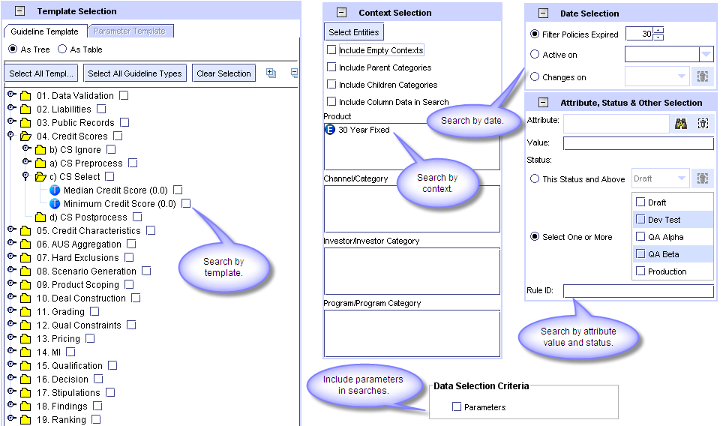

Figure 21: There are many ways to retrieve guidelines.

Set up your search criteria on the left, click the Search Policies button and view the results on the right. Double click a guideline to go to the Edit Guidelines screen or perform group operations using Shift+Click and Control+Click to select the guideline(s) you want to process.

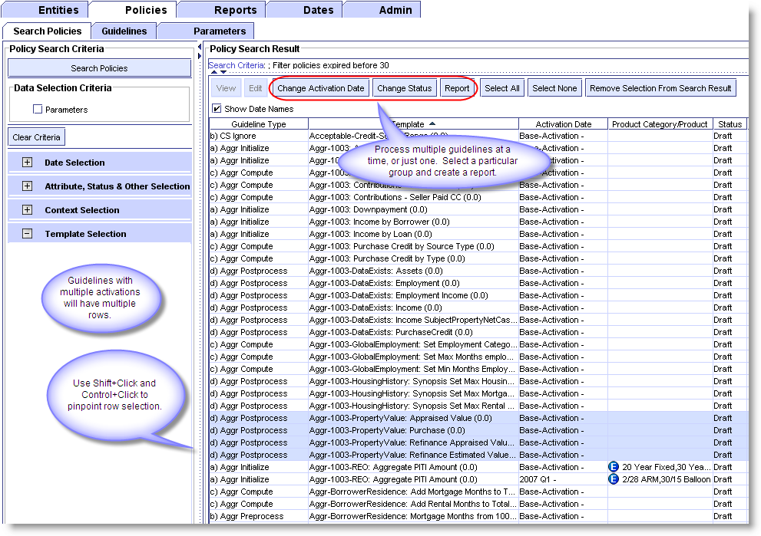

Figure 22: Guideline search results.

When a guideline appears more than once in the listing check its dates: the Search Policies screen returns all the activations of a guideline. For more information on searching for guidelines based on template, context, date, attribute, and status, see the *PowerEditor Reference Manual.* It provides a detailed overview and procedures.

# Working With Guidelines

There are two ways to create new guidelines in PowerEditor. You can copy an existing guideline and edit it to create a new version, i.e., activation of it, or you can create a new guideline from scratch. Both methods are described below.

## Creating a New Guideline Activation

Here’s an overview of the editing tools on the Edit Guideline screen (Figure 23).

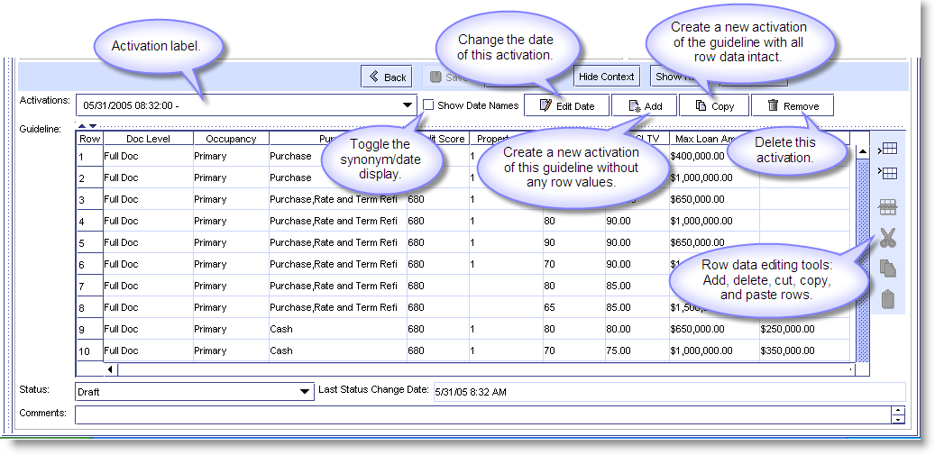

Figure 23: Tools for managing activations.

Activation tools include:

* Edit Date button – changes the date of an activation.
* Copy (Activation) button - creates a new activation of the guideline with row data intact.
* Add (Activation) button - creates a new activation of the guideline without any row values (a copy with one empty row).
* Remove (Activation) button – deletes an activation.

Use the Copy Activation button when changes to row data will be minimal; use Add Activation when there will be little similarity between the old row values and the new row values. The new activation will have the same template and context as the original. When working with a guideline that has multiple activations, it’s a good idea to check the activation label to make sure you are editing the right version.

Note the difference between the Activation controls and the grid editing icons, stacked vertically to the right of the grid.

* Use Edit Date, Add (Activation), Copy (Activation), and Remove Activation) to act on the guideline as a whole, e.g. to copy an activation of a guideline.
* Use the editing icons in the bar to the right to manipulate the contents of the grid, i.e. to copy rows or cells and their contents.

Different activations of a guideline should not overlap, i.e., be in effect for the same time period. When adding or copying you can set the existing activation to expire automatically (as of the new one’s effective date) by checking the “Enable Automatic Adjustments to Other Activations” box (Figure 24).

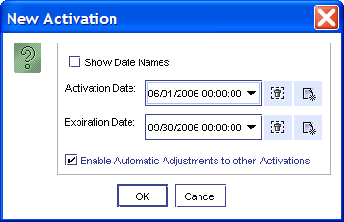

Figure 24: Set an activation to automatically retire.

## Creating a New Guideline

To create a brand new guideline use the Manage Guidelines screen.

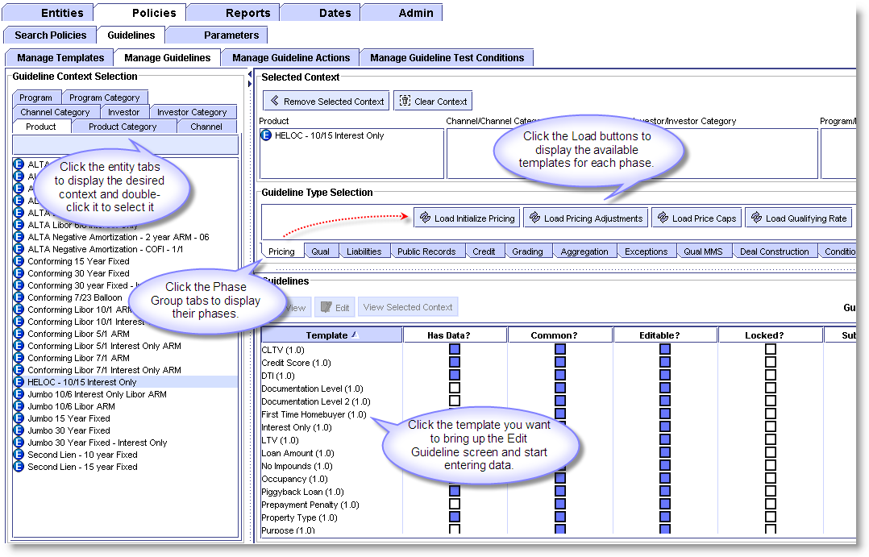

Figure 25: Creating a new guideline on the Manage Guidelines screen.

To create a new guideline:

1. Use the entity and category tabs to display the context elements you want and double-click them to insert them in the context boxes on the right. For each entity type you can select an entity or a category, but not both. Remember: set too much context and your guideline rows won’t fire when they should; set too little context and the rows will fire more than necessary.
2. Click the Phase Group tabs to display the phases they hold.
3. Click the Load buttons to display the available templates for each phase.
4. Select the template you want for the new guideline and double-click it to bring up the Edit Guideline screen.
5. Click the Add (Activation) button to establish the initial row of the guideline.
6. Use the editing tools to add more rows and enter the guideline data.
7. Click Save.

For more information about this screen and detailed instructions for creating a new guideline see the *PowerEditor Reference Manual.*

## Using One Guideline to Make Another One

As you know, one way to use an existing guideline as a starting point for a new one is by using the Copy Activation button. This makes a new activation with the same context as the original.

You can also use an existing guideline to make one with a different context. You might suppose that creating a copy and changing its context would do the trick. Unfortunately, it’s not that straightforward: not only will doing this not work, it could get you into hot water.

IMPORTANT: When you Copy an activation and edit its context, *both the copy’s context and the original’s context* are changed.

So to create a guideline with a different context, use the procedure below.

To use an existing guideline as a starting point for a new one with a different context:

1. Bring up the guideline you want to use on the Edit Guideline screen.
2. Highlight the rows you want and use the Copy tool on the editing toolbar (not the Copy Activation button) to copy them to the clipboard. As an additional step you can paste them into an Excel spreadsheet as a backup.
3. Using the Manage Guidelines screen, create a new guideline with the context you want.
4. Click the Add Activation button and use the editing tools to add enough rows to hold the guideline data waiting on the clipboard (or in the spreadsheet).
5. Paste in the rows.
6. Make any required edits to the row data.
7. Run Validate and Save.

## Taking Status Into Account

Obviously, you can edit guidelines that are under development more freely than you can edit production guidelines. Here are a few things to keep in mind when working with guidelines at different points in the development cycle (Draft, QA, Production, etc.).

* When making a new version of a production guideline using the Add or Copy buttons set the old version to expire at the same time the new one goes into effect. You can have PE do this for you by checking “Enable Automatic Adjustments to Other Activations” box in the Activation dialog.
* Under most circumstances production guidelines aren’t deleted, they’re expired.
* Guidelines not yet in production can usually be modified without creating a new version of them first. Likewise, under many circumstances it’s OK to delete a draft guideline or activation using the Remove button. Just remember to think things through first: PowerEditor does not have an Undo button.

## Validation: Running A Data Entry Check

Use the Validate button on the Edit Guideline screen to run a check on an activation’s dates and data. You have the option of checking every activation of the guideline or just the current one.

The All Activations option runs an Effective Date overlap check, a Rule Overlap check, and Completeness and Consistency checks on every activation of the guideline. If you select the “This Activation” option—and the template builder has activated the validation controls— Validate performs all the checks listed above except the Effective Date check. If you routinely get consistency errors it may be because the template has not been set up to handle validation effectively. Speak to your MindBox consultant or the template author.

* the Effective Date check checks for date overlaps between activations of a guideline.
* the Rule overlap check checks for duplicate rows in a guideline; each row must be unique.
* the Completeness check checks for any holes in the grid values.
* the Consistency check checks for any overlap in the grid values.

Here’s an example (the values on the left represent adjacent cells in a row):

0-50 60-100 These values would generate a completeness error (range gap between 50 and 60).

0-50 40-100 These values would generate a consistency error (range overlap between 40 and 50).

0-50 Null These values would also generate a consistency error: zero and null overlap because they have same value.

## Making Group Changes to Multiple Guidelines

On the Search Policies screen you can perform group guideline operations. Select the guidelines you wish to modify (Control+Click and Shift+Click come in handy here), and select the Change Activation Date or Change Status buttons.

## Deleting Guidelines & Activations

Guidelines that are in production are typically retired/archived, rather than being deleted from the system. Activations that have expired are left in place for historical reasons and accounting purposes, but after some period of time it may be appropriate to delete them.

 To delete an activation:

1. Display the activation you want to delete on the Edit Guideline screen. Make sure the right one is selected from the pull-down list in the Activations field.
2. Click the Remove (Activation) button.

## A Quick Tour of PE’s Data Entry Fields

### Check Boxes and Drop Down Lists

Different PowerEditor fields take data values in different ways: some take numbers and characters straight from the keyboard, there are also check boxes, drop down lists, fields that take multiple values from a list, and numeric range fields. (Date fields are discussed in Section 1.3.) Descriptions of these fields and tips for using them appears below.

Check boxes are straight forward: they toggle between two values, such as “Assumable: ☒ Yes.”

Fields that take a single value from a drop down list are marked by a triangle at the right-hand edge. If no value is required a blank line will appear at the top of the drop down list.

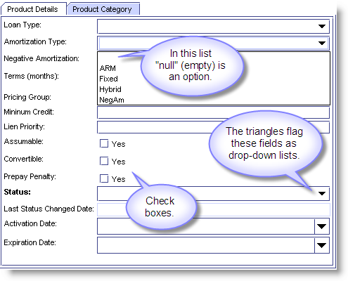

Figure 26: Checkboxes and drop-down lists.

In a grid cell that takes multiple values double-clicking will bring up a dialog with a list. Use Control+Click to select and de-select values (Figure 27). Hint: to deselect all, Control+Click on each of the selected items.

When you see a red “NOT” in a guideline’s cell it indicates that the Exclude Selections option has been used to insert the cell’s values.

Checking the Exclude Selections box places all the values you’ve selected in the cell with a NOT in front of them. When using this option—especially when working on exclusion templates—think through your logic carefully, it’s easy to create double negatives, with the opposite effect of what you intended.

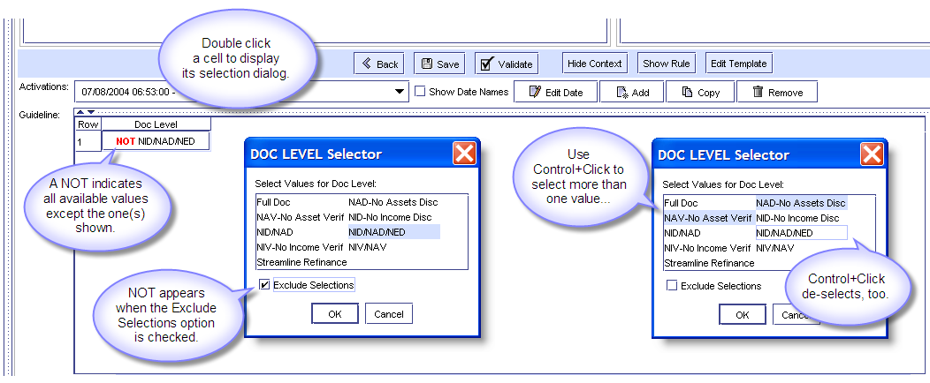

Figure 27: Select multiple values from a special dialog box.

### Entering Numeric Ranges

When entering values into grid cells that take a numeric range, e.g. loan-to-value ratios (60-65%, 65-70%, 70-75%), the Edit Range dialog appears (Figure 28).

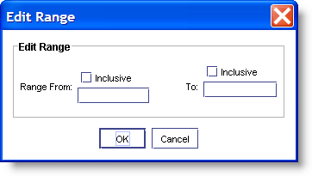

Figure 28: The Edit Range dialog.

For floats, e.g., 90-90.9999, you have to use the inclusive

Use the Inclusive box to pinpoint your range endpoints. Figure 29 shows the effects of checking or not checking the Inclusive box for the range 1-5. (Note that the range value notation also varies, depending on how Inclusive has been used.)

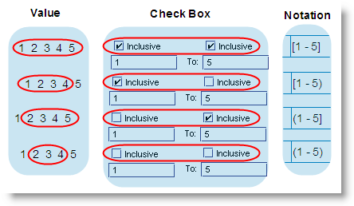

Figure 29: Actions of the Inclusive box.

# Editing Messages

PowerEditor messages provide a useful way to provide feedback to customers (and other people interacting with the system) about the decisions it has made and the actions it has taken. For example, a message might let a customer shopping for a mortgage know that, "An LTV greater than 90% on Interest Only loans is not allowed." Messages can also provide valuable feedback regarding which rules have fired and when, which is useful information for people creating templates.

To edit a message or create a new one, go to its template (Figure 30). You can do this from the Manage Templates screen, or on the Search Policies screen by hitting the Edit Template button.

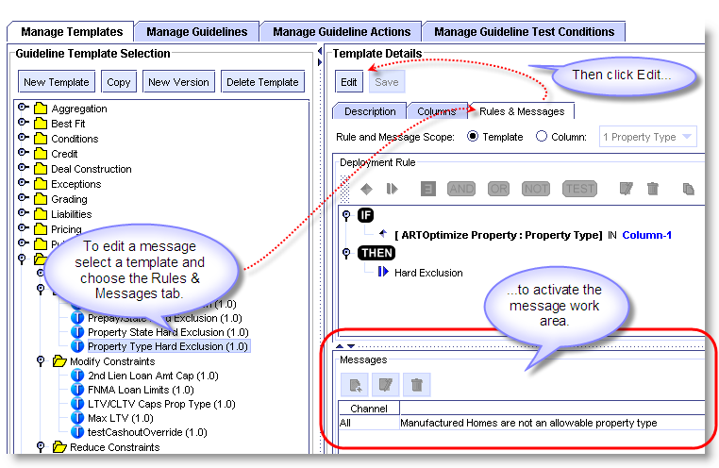

Figure 30: Selecting a template to edit its message on the Manage Templates screen.

## Using Message Arguments

Many effective messages are just plain strings of text. But you can incorporate arguments into a message so that data from your guideline, or elsewhere in the knowledge base, will be inserted by the decision engines at runtime. Messages can contain any number of arguments, and arguments can appear anywhere in the message.

Use arguments to make messages more meaningful. For example, here are two messages to someone shopping for a mortgage in Hawaii, from a company that does not lend in Hawaii. The first is a basic text string, the second uses an argument to pass a value from the applicant’s 1003:

1. “Lending in some states is currently not permitted."

2. "Sorry, we are not lending in Hawaii at this time.”

For Business Analysts the two most useful types of message arguments are attribute arguments, and column arguments.

### Attribute Arguments

Use attribute arguments to insert data from anywhere in the knowledge base. You can use any attribute, whether it’s used in the template you're working on or not.

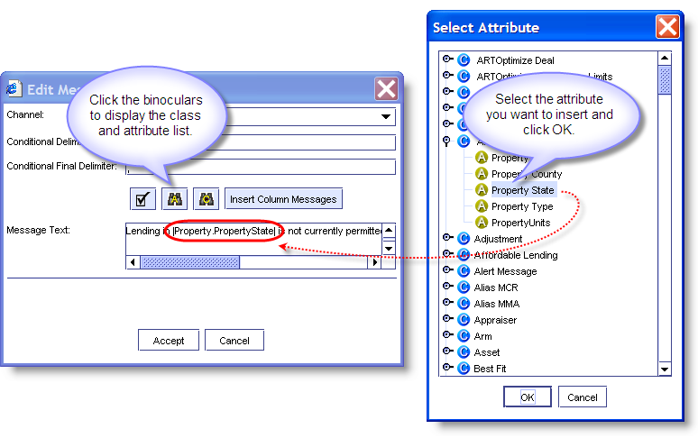

Figure 31: Using a lookup to select an attribute for a message argument.

### Column Arguments

Use a column argument to insert a value from a guideline grid.

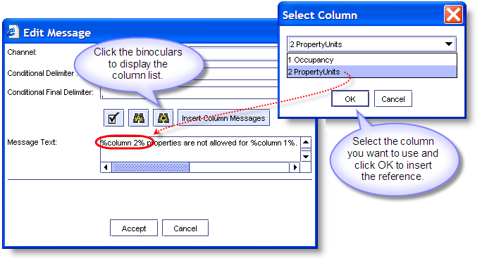

Figure 32: Inserting a column argument into a message.

## Message Syntax

In the Message Text field attribute arguments appear in the message work area enclosed by vertical bars called *pipes*, e.g., Lending in |Property.PropertyState| is not currently permitted. Column arguments are enclosed by percent signs: %Column 2% properties are not allowed for %column 1%. This syntax is inserted for you when you use the lookup dialogs, but you can enter argument strings and their syntax directly from the keyboard if you’re so inclined.

Attribute and column arguments should meet most of your message needs. To learn more about the other Edit Message dialog options (i.e. the Channel, Conditional Delimiter, Conditional Final Delimiter, Final Delimiter and Insert Column Messages fields), please see the *PowerEditor Reference Manual*.

## Anomalies In An Attribute Name

Occasionally you may notice a difference between the name of an attribute in a template rule and the name of the same attribute in a message argument (Figure 33).

This happens when the attribute’s definition in the object model differs from its PowerEditor “display label.” If this happens when you’re working on a message (or any other time you’re doing an attribute lookup) just remember to lookup the attribute name used in the template rule.

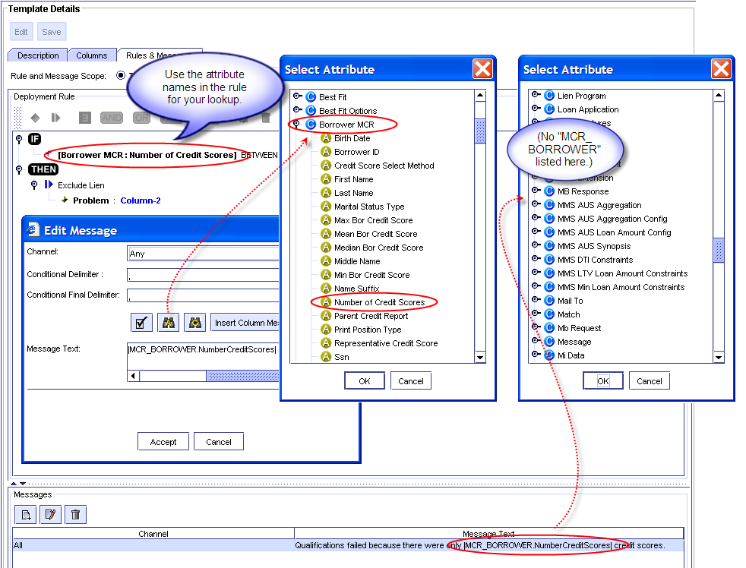

Figure 33: Use the attribute names as they appear in the rule.

Actually, MindBox attributes have three names: the object model name, the display label name, and the deploy value. You usually see display label names in PE, though object model names make an occasional appearance (e.g., in message arguments and in the Manage Template screen’s Attribute Map field). Deploy values never appear in PowerEditor, they’re used only by the decision engines. All three names appear side-by-side in the domain file, e.g., *MMSDomain.xml.*

# Working With Products And Other Entities

This section describes some of the tasks Business Analysts perform using product entities, but everything described here applies to every other entity type as well.

## Retrieving Product Information

Use the Manage Product screen (under the Entities tab) to search for and retrieve products. There are a number of search options available. Use the Navigate tab to find products associated with specific categories in the product hierarchy. Use the Filter tab to search for products based on specific attributes, e.g., Product Name, Product Description, Amortization Type, etc., or combinations thereof. Once you’ve selected your criteria, hit the Search Product button to display the results of your search. You can also save your entity search criteria settings in a filter for re-use later. See the *PowerEditor Reference Manual* for more information creating on search filters.

## Editing Product Information

To edit the definition of a product, select it from the search results list and click the Edit key to activate the Product Details pane. Fill in, add to, or edit the information in the product fields. Click on a field to display a list of available options from the pull-down list, or use the arrows on the right-hand side of the screen.

## Adding a Product to an Existing Category

Use the Product Category tab to add a product to an existing category (i.e, to associate a category with a product, which is the same thing), and to change a product’s category associations. Use the check boxes to the right of the product hierarchy to make or change the necessary associations. Click the Save button when you’re finished making additions or changes,.

# Reports

PowerEditor provides a tool for creating a number of basic guideline reports. A wide variety of customized PowerEditor reports can also be generated using Crystal Reports software. See the PowerEditor Custom Reports Guide for more information on using the Crystal Reports tool.

To create a basic guideline report:

1. Search for and display the guidelines and activations you wish to report on using the Search Polices screen.
2. Select the ones to include in the report (Control+Click and Shift+Click are handy here).
3. Click the Report button and select the elements you want in the report and the name of the report file (Figure 34).

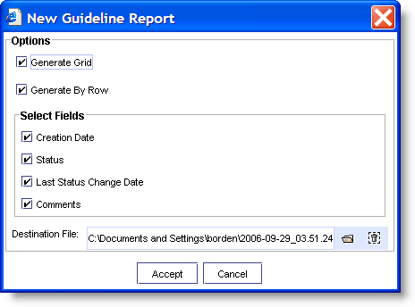

Figure 34: The Guideline Report dialog box.

Figure 35 shows a sample guideline report.

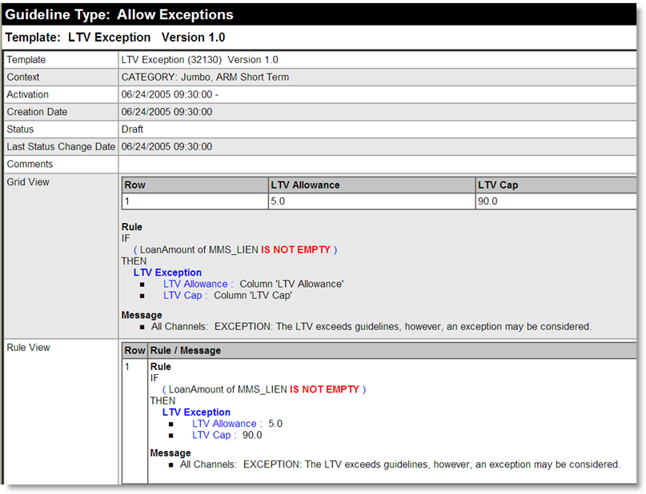

Figure 35: Sample Guideline report.

# Appendix: Glossary

The following glossary provides definitions of many PowerEditor elements. For more information about these things please refer to the *PowerEditor Reference Manual.*

|  |  |
| --- | --- |
| Actions | Rule clauses on the Action side of a rule. See Template Rule. |
| Activation, Activation Date, Activation Label | An activation is a version of a guideline effective for a specific period of time. A guideline’s activation date is its effective date. A guideline’s activation period, as determined by its start and end dates, is called its effective date range.  A guideline’s Activations field (Edit Guideline screen) is its activation label. Use this field to create new versions of a guideline and retire old ones. Though different activations of a guideline will have different effective dates and grid values, they will all share same template and context. |
| Effective Date Range | See Activation. |
| Message Argument | See Message. |
| Attribute | A quality or characteristic of an object class. For example, attributes of the class “Borrower” would include Name, Address, and CreditScore. See Object Model. |
| Category | A collection of related entity information, e.g., the category, “Fixed 30 products.” See Context. |
| Channel | A frequently used mortgage-related entity. See Entity. |
| Class | A data object. The MindBox object model defines all the objects in a particular business’s “domain,” e.g. “Property,” “Borrower,” “Loan,” and “Income.” See Object Model. |
| Column Message | A message associated with a single column in a template, rather than every column in the template. See Column Rule. |
| Column Rule | A template rule associated with a single column, rather than every column in the template. Useful when the columns apply generally to a particular business policy, e.g. “Adjustable Rate Mortgages,” except one (“Jumbo ARMS”). |
| Context | Context connects entity information (e.g. product) with a particular set of guidelines. A guideline’s context indicates which entities (e.g., products, programs, investors, channels) it applies to. See Entities. |
| Date Synonym | A descriptive, alphanumeric date “stand-in,” e.g. “New Years Day,” “June 15 Upgrade.” A synonym can be used anywhere a date is required in PE. Changing a synonyms date changes its value everywhere its used in the system. |
| Deploy | To extract information from PE and generate ART*Script, the language used by the MindBox decision engines. |
| Deployment Status | A code assigned to guidelines, that indicates where it is in the system development process, e.g., “Draft,” “QA,” “Production.” |
| Entity | A PowerEditor object that holds information about products or other things you want to associate with different sets of guidelines, e.g., Fixed 30 products. Entities are used to associate specific products (or investors, programs, etc.) with specific guidelines. |
| Enumerated List | A field for which one or more allowed values may be selected, e.g., Loan Type: Conforming, Jumbo, FNMA. In the object model enumerated attributes have a list of allowed values in their declaration. |
| Guideline | PowerEditor guidelines hold business policy data information in PE-readable form. Every guideline has six elements: a grid, a context, an effective date, a deployment status, a template, and a phase. |
| Guideline Type | See Phase. |
| Investor | A frequently used mortgage-related entity. See Entity. |
| LHS | The Left Hand Side of a rule. See Template Rule. |
| Object Model | Wikipedia defines an object model as, “A collection of objects or classes through which a program can examine and manipulate some specific part of its world.” For example, in a payroll system “Company” and “Employee” would both be objects. “Employment” would be one of the relationships between them. The attributes of the object class Employee would include Name, Address, and Birthdate. Values of those attributes might be “John Doe,” 123 Main Street,” and “March 8, 1975.”  The MindBox object model defines all the data elements (i.e. objects) in your business’s domain and the relationships between them. An object’s class name and attribute name form a unique identifier for it in the MindBox system. Class and attribute information can be seen in template rules. |
| Parameters | Special templates that contain static information, most of which is used to configure the decision engines. |
| Phase | A segment of decision engine processing. In PE engine phases are organized into groups, e.g. Qualification, Liabilities, Public Records, Credit Scoring. Credit Scoring (CS) phases include CS Ignore, CS Preprocess, CS Select, and PS Postprocess.  A template’s phase (and by extension, a guideline’s phase) denotes where in the decision process it will be employed by the engines. |
| Policy | A company’s business policies. The MindBox PowerEditor is used to implement and modify automated business policies. |
| Product Hierarchy | A structured collection of products, categories, and sub-categories in PE. |
| Program | A frequently used mortgage-related entity. See Entity. |
| RHS | The Right Hand Side of a rule. See Template Rule. |
| Rule | See Template Rule. |
| Status | See Deployment Status. |
| Synonym | See Date Synonym. |
| Template | The PE component that provides guidelines with their logic and structure. Templates set a guideline’s columns, provide the case-based logic (e.g. If/Then, or Condition/Action) for each guideline, and contain any associated messages. |
| Template Rule | The IF/THEN logic encoded within a PowerEditor template. The IF, or condition side of a rule, defines the conditions under which it will fire. Sometimes called the Left Hand Side (LHS) of a rule. The THEN, or Action side of a rule, defines the action to be taken when the rule files. Sometimes called the Right Hand Side (RHS) of the rule. Rules are comprised of data object and grid values. |
| Usage Type | See: Phase |